# MEASURING BUSINESS IMPACT AND MITIGATING BIAS

## Introduction to Business Impact

This chapter covers steps required to measure business bias and Scale AI product

Key Topics

* Benefits & Challenges of AI initiatives
* Define and measure success metrics
* A/B testing & Versioning
* Monitor & mitigate bias
* Continuous learning
* Compliance & ethics
* Scale

## Case Studies and Challenges

### AI Benefits

AI’s leading benefits are enhancing products and processes and better decisions

Survey showing the AI benefits for companies.

1. Enhance current products
2. Optimize internal operations
3. Make better decisions – eg: fraud detection
4. Optimize external operations
5. Free workers to be more creative
6. Create new products
7. Capture and apply scarce knowledge
8. Reduce headcount through automation
9. Pursue new markets

### Case Studies

1. **NETFLIX** - Netflix found out improving search results using AI, user frustration and customer churn can be prevented. They manage to save US$1 billion a year in potential lost revenue.
2. **BLUERIVER technology –** Agricultural business where they used see and spray technology thereby saving on pesticides and at the same time targeting only the weeds and not the crops. Their equipment had visual intelligence which used computer visual algorithms to identify plants and only spay weeds. They managed to save 50% reduction in seeds costs and 90% in herbicide costs . They were also environment friendly.
3. **Manufacturing Industries (GE) –** Using AI to predict failure in advance and thus help in savings.

### Challenges of AI Implementation

Companies are however facing challenges when they seek to implement AI

Top challenges are

1. Implementation Challenges
2. Integrating AI into the company’s roles and functions
3. DATA issues (data privacy, accessing and integrating data)
4. COST of AI technologies / solution development
5. Lack of Skills
6. Challenges in measuring and proving business value

## Measuring Success

There is a huge gap between research into AI and delivering tangible business results.

As per Forrester survey only 58 % of businesses have considered AI but only 12% out of those companies put AI into practice.

Defining business goal and success metric is the first steps

1. Business goals – for different industries the goals may differ
2. Revisit success metrics
   1. Customer Experience
   2. Revenue Gain
   3. Customer Engagement
   4. Business process automation
   5. Better & faster decision making

## Outcome vs Output

AI products must be deployed to deliver business outcomes. Focus on outcome and not output. Monitor the output of AI model (accuracy, performance, fairness) and understand the reasoning behind the results.

The table below provides the metrics for business outcome vs model output.

|  |  |
| --- | --- |
| **OUTCOME** | **OUTPUT** |
| Generate Revenue | Accuracy |
| Improve Customer Experience | Execution time |
| Increase user satisfaction | Recall |
| Automate & Save cost | Precision |

## Chatbot Example

Key Success Metrics for chatbot are shown in table below

|  |  |
| --- | --- |
| **Success Metrics** | **Associated Business Metric** |
| Number of Active Users | Conversion Rate |
| Number of bot sessions initiated | Customer Support Savings |
| Average Chat sessions | Increase in Net Promoter Score |
| Average chats handled by bot | Cost per Acquisition |
| Number of new users using bots daily, weekly, monthly | Lift in Engagement |
| Number of Active Users | Customer Retention rate |

After measuring the metrics should be benchmarked against the goal and keep improving and optimizing the machine learning model and user experience.

Some key metrics to collect data and carry out benchmarking against goals.

1. User adoption & retention
2. User engagement
3. Conversion rate
4. Self-service rate
5. User satisfaction

**Net promoter scale** – calculates based on responses to a single question “How likely is that you would recommend our company/product/ service to a friend or colleague?”. The scoring is often based on a 0 -10 scale.

**Cost per acquisition (CPA)** – online advertising pricing modle where the advertiser pays for a specified acquisition eg: sale, click, form or submit

## A/B testing & Versioning

A/B testing helps to make data driven decisions when it comes to evolving the product and improving it.

It is very common to send about 20% of your customers to a new model (v2, a "challenger" model) and 80% to a well-tested model (v1, a "controlled" model). This way, you can get some good experimental data and really see if the v2 of your model does indeed work better; if it does, you can then switch all user traffic (100%) to that new model.

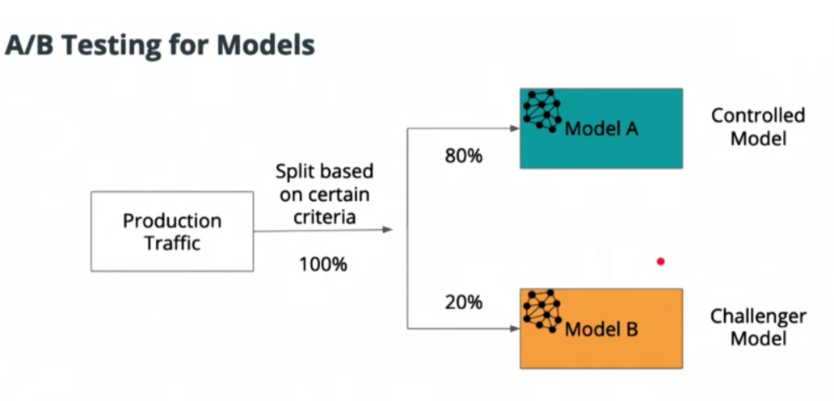

**Avoid a major pitfall of declaring success to soon in A/B testing.**

Designing A/B test for models (best practices)

1. Deciding on performance metric
2. Deciding on test types based on performance metric
3. Choosing a minimum effect size to detect
4. Determining sample size
5. Running the test until sample size is reached
6. Cost benefit analysis (eg: is 10% accuracy gain beneficial for business)
7. Run the test long enough to capture any seasonality effects
8. Control to experiment to avoid novelty effect -initial positive reaction that wears off

## Monitor Bias

Monitoring and mitigating bias should be an ongoing initiative as AI product is launched and scaled.

Bias – AI systems are only as good as the input data. Bad data can contain racial, gender and ideological biases.

Examples of bias

* Some Accents don’t work for voice assistants – Alexa and google assistance are 30% less likely to understand non-American accents
* Facial recognition is more biased towards white, male faces.

Different types of Bias

1. Model Bias – when model itself generates biased outcome
2. Data Bias - when unbalanced selection of source data is used
3. Annotation Bias – introduced by humans annotating and generating the training data

Some of this bias can be mitigated by involving a diverse team of developers and going through rigorous audits to test for quality and use-case coverage.

## Addressing Unwanted Bias

Identify all unwanted bias and come up with remedies based on **target user base and business needs.**

**Handling Unwanted Bias**

1. Awareness – define the decision you are asking the model to solve for. eg: - a model detecting human (does cartoon count, does only a visible hand count.). It’s really important to define properly.
2. Data – collect data from multiple sources. Cover for enough examples and edge cases. Have diversity in data collection and model development.
3. Iteration and Learning is ongoing process. Be transparent, take feedback, be empathetic.

## Continuous Learning

Continuous learning involves a feedback loop between human and machines that eventually tunes the machine learning model.,

The figure below shows the flowchart for continuous learning.

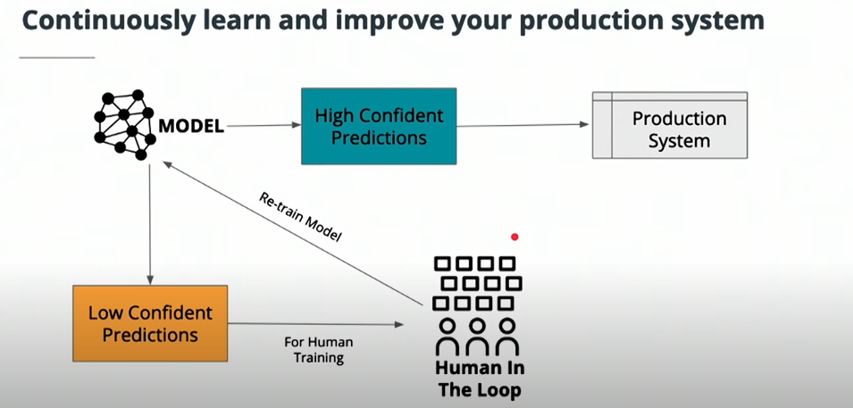

SMART Selection

Instead of processing all unlabeled data use smart selection method. Select the most relevant data that can improve the accuracy of model. Discard harmful data.

Smart selection has 4 key criteria

1. Low confidence – Any data type that model has lower confidence in
2. Uncertainty – Scenarios that model is unable to predict
3. Novelty – any new data that comes up and model has never trained on that
4. Class importance – identify the classes that are important for the model and the data related to those classes are given higher priority

## Spam Filter

Real world example of Spam Filter

1. Filter email with machine learning – first use machine learning to filter email. This has accuracy of about 80%.
2. User corrects mislabeled spams – Users will correct the mislabeled spams.
3. Retrain model with user data – Use the data that users are relabeling
4. Accuracy improves with time – Iterate the whole process to improve model.

## Model Optimization & Staleness

Apart from model accuracy, recall and precision and also important.

Recall – Percentage of total relevant results correctly displayed by model

Precision – Proportion of data points which model says was relevant were actually relevant

Example – for cancer diagnosis a false negative is completely unacceptable (person having cancer is told that they don’t have cancer).hence recall is more important in this case.

However, for you tube recommendation system, precision is more important.

Some models (example fashion industry) are at risk to staleness. So, models must be refreshed over time.

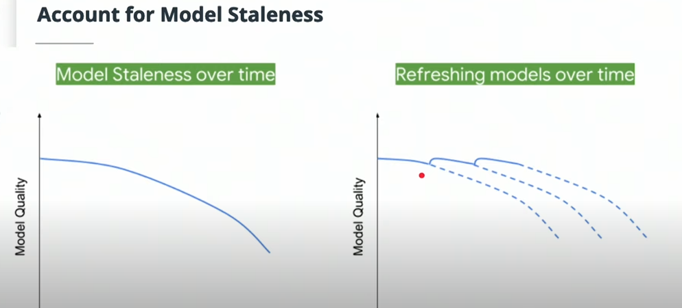

Important points to consider for Model refreshing

* Not all models are at risk – eg: model predicting cats and dogs images.
* Unwanted feedback loops – This can affect model performance.

## Compliance and Ethics

AI is used for different fields like Granting parole, granting credits, autonomous weapons. AI is raising serious questions about compliance and ethics.

41% of voice assistant users have concerns over trust and privacy. Hence building user trust is important factor for AI product managers.

Another example – San Francisco has banned facial recognition technology due to concerns around potential abuse of the system.

## Privacy-First Approach

AI should be built with ethics and compliance.

**The world’s most valuable resource is no longer oil but data (The Economist)**

Some important factors about data

1. Huge amounts of high values business data is involved
2. Balancing features and attributes vs model accuracy/business goals
3. A lot of stakeholders are accessing, enriching and refining the data in AI product lifecycle.

Privacy first approach should be there

1. Data laws and AI coexist with privacy first approach
2. Deeper understanding & governance of data
3. Understand the sensitivity of data
4. Obtain explicit consent and explain to customers how their data will be processes.

The figure below shows the key considerations from privacy point of view.

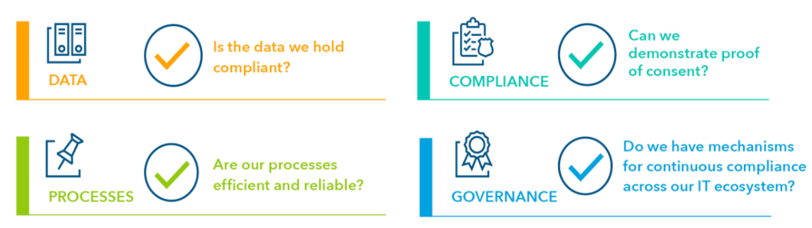

## Scaling a Product

Organize for Scale

1. Machine architecture
2. Organizational Structure

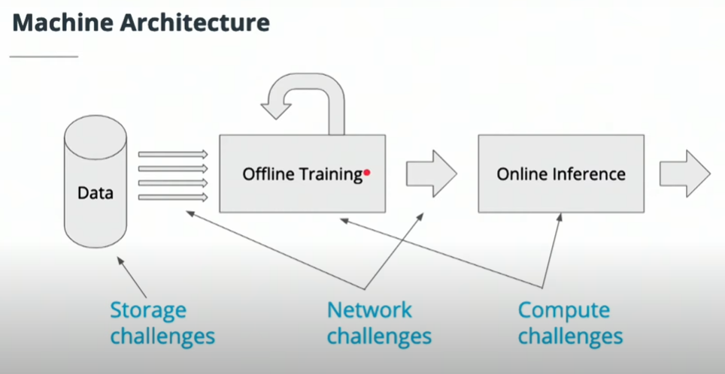

As AI is scales, organization structure becomes quite important. cross functional coordination and planning is required.

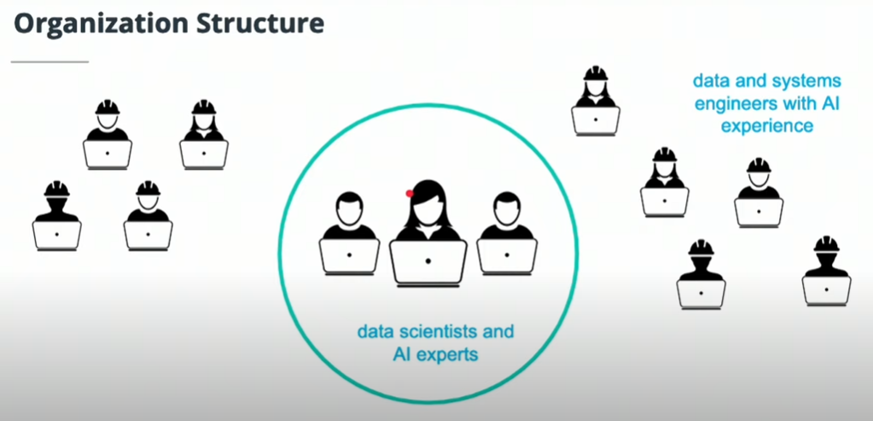

## Summary of Skills

1. AI beings a lot of business benefits
2. Measuring success metric
3. Continuous learning of models
4. Monitoring and mitigating bias
5. Security & data privacy

## QUIZ FOR NOTES

Which of the following bias is introduced by humans while generating the training data?

1. Model Bias
2. Annotation Bias
3. Data Bias
4. None of the above

**Answer – B**

Which of the following are business outcomes? Select all that apply?

1. Model accuracy
2. Generate Revenue
3. Improve Customer Experience
4. Model execution time

**Answer – B & C**